

**The McMinnville Public Library**

**Invites you to apply for the exciting position of**

**Librarian III, Reference**

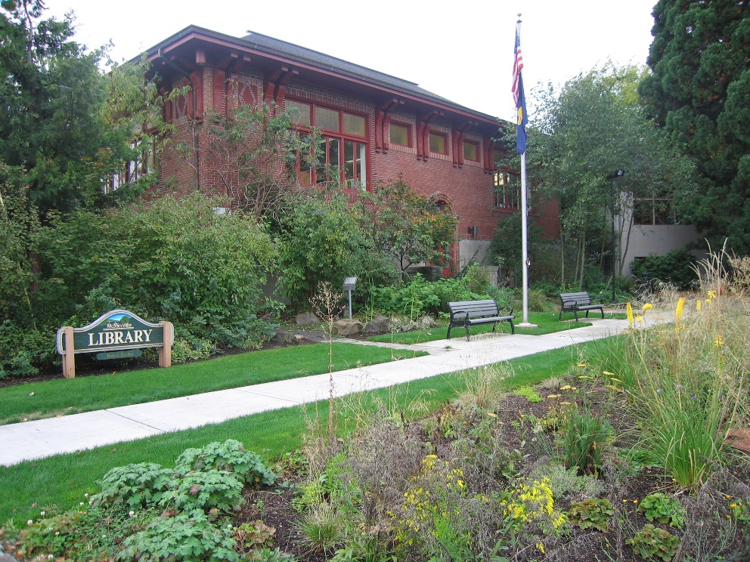



**LIBRARIAN III**

**Reference**

# $3,992 - $5,094/month

# GENERAL DESCRIPTION OF THE DUTIES

The Librarian III performs professional level library and information services for the public. Those working in this position are required to perform the most complex duties in Library services to the public. In addition, the Librarian III is a working supervisor; managing staff and work flow and handling administrative duties.

# SUPERVISION RECEIVED

This position receives direct supervision from the Library Director.

# SUPERVISION EXERCISED

This position participates in supervision of professional and paraprofessional staff of a lower classification and volunteers and is part of the Library’s Management Team.

# ESSENTIAL DUTIES AND RESPONSIBILITIES

The duties and responsibilities listed should not be construed to be all-inclusive. The specifics of each responsibility are dependent on each Librarian III focus: reference, children’s services, or circulation. The essential job duties will include other responsibilities as assigned and required.

1. Supervises Library staff, including recommending the hiring of staff; scheduling, training, assigning, and reviewing work; evaluating performance.
2. Participates in the recommendation of and/or taking disciplinary actions and responds to and resolves employee complaints under direction of Library Director.
3. Develops, implements, and evaluates Library programs and processes in a team environment.
4. Recommends and facilitates implementation and maintenance of policies, procedures, and services within the Library.
5. Monitors and maintains Library records.
6. Exercises independent judgment to plan, organize, and carry out duties of Library services to the public.
7. Interacts with the public to solve customer complaints.
8. Maintains and oversees purchasing and budget and revenue tracking in assigned area.
9. Acts as a liaison to community agencies, Library consortium members, and civic groups.
10. Conducts reference interviews and directs customers to appropriate internal and external sources.
11. Instructs patrons in the use of Library materials and technology.
12. Troubleshoots computer problems and reports issues as required.
13. Provides information to patrons regarding Library policies, procedures, and programs.
14. Provides outreach to the community; assists in bringing services beyond the Library walls.
15. Promotes library events and services inside and outside the Library.
16. Performs tasks associated with selecting, ordering, and maintaining Library materials in specific collections; keeps appropriate records.
17. Collects and organizes necessary reports and statistics.
18. Communicates effectively with Library staff and supervisors, other City employees, and members of the public.
19. Trains staff in areas of expertise related to Library service.
20. Provides assistance in other Library areas based on workload needs.
21. Maintains proficiency by attending workshops and conferences, working on City and professional committees, professional reading, and meeting with others in areas of responsibility.
22. Performs work in accordance with federal, state, City, and Library employment and safety laws, rules, and standards.

# KNOWLEDGE, SKILLS AND ABILITIES

## ***Knowledge of:***

* Principles and practices of library science and the philosophy of public library service specific to assigned area
* Integrated library systems
* Principles of customer service
* Technology in public libraries

## ***Skills in:***

* Using technology in service to the public
* Conducting reference interviews to understand customer’s needs
* Communicating effectively with others from diverse backgrounds
* Coordinating and managing people and workflow

## ***Ability to:***

* Establish and maintain effective working relationships with the general public, local officials, and employees
* Work in a team environment
* Maintain confidential and sensitive information
* Exercise independent judgment to plan, organize, and carry out duties
* Apply rules and regulations
* Ability to manage effective meetings

# EDUCATION AND EXPERIENCE

Any equivalent combination of education and experience that demonstrates the knowledge, skills, and abilities to perform the essential duties and responsibilities of Librarian III is qualifying. A typical way to qualify would be a Master’s Degree in Library Science (MLS) and at least two years of professional library work experience.

# DESIRABLE EXPERIENCE, TRAINING AND LICENSES

A Master’s Degree in Library Science (MLS) is preferred. Fluency in English and Spanish is preferred.

# PHYSICAL DEMANDS

While performing the duties of this position, an employee is frequently required to stand, sit, communicate, reach and manipulate objects, tools or controls. The position requires mobility and visual acuity. Duties involve moving materials weighing up to 10 pounds on a regular basis such as files, books, office equipment, etc., and infrequently weighing up to 25 pounds. Manual dexterity and coordination are required less than 50% of the work period while operating standard library or office equipment. Qualified individuals with a disability and known limitations will be reasonably accommodated to perform the essential functions of this position.

**WORKING CONDITIONS**

Usual library working conditions as well as occasional visits to off-site settings. Evening and weekend hours are required.

**COMPENSATION**

The salary range for the Librarian III is $3,992 - $5,094/month, depending upon qualifications.

The City of McMinnville provides a benefit package that includes:

* Medical, dental, and vision insurance in which the City and employee share in increases to premiums over the base cost established in 1991-92
* City-paid life insurance
* City-paid disability insurance
* Sick leave earned at the rate of eight hours per month
* Vacation credit earned at the rate of 6.67 hours per month up to a maximum of 320 hours, with increases in accrual rates after 3, 7, 13, and 20 years
* Ten paid holidays and two floating holidays annually
* Full, City-paid participation in the Oregon Public Service Retirement Plan (OPSRP)
* Opportunities for on-going professional development
* Options to participate in the credit union, deferred compensation plan, and other employee-paid insurance

**THE CITY OF MCMINNVILLE**

The City of McMinnville and the community have many advantages to offer the Librarian III including a supportive Mayor, City Council, City Manager, staff, and community. Historic Downtown McMinnville was recently recognized by Parade Magazine as the best downtown west of the Mississippi River. McMinnville’s historic Third Street was also recently honored by the American Planning Association as one of its prestigious Great Streets in America. McMinnville is a full service city, providing a broad range of public services, and has a statewide reputation for stability and effective governance. It is the City’s mission to maintain a safe, livable environment within the community through open governance and the efficient delivery of public services. A recent citizen survey rated the City’s livability at 8.1 out of 10. The small-town atmosphere, the historic downtown area, and community spirit were most highly valued by those responding to the survey.

**TO APPLY**

Those interested in applying for the position of Librarian III, Reference should submit the City of McMinnville’s employment application (can be obtained online at ww.mcminnvilleoregon.gov), a cover letter, and a current resume that highlights relevant experience and education related to the position. Application materials (completed application, cover letter, and resume) must be received no later than 5:00 pm on Friday, October 20, 2017. Application materials should be submitted (via regular mail, email, or facsimile) to: Erica Thomas, Administrative Specialist 230 NE Second Street McMinnville, OR 97128, Email: [erica.thomas@mcminnvilleoregon.gov](mailto:erica.thomas@mcminnvilleoregon.gov), or Fax: (503) 472-4104. Ms. Thomas is also available to answer any questions from those who need additional information regarding this position or the recruitment and selection process. Please contact her at 503.434.2328 or by email at erica.thomas@mcminnvilleoregon.gov. The Selection Process Applications and resumes will be screened and evaluated during the week of October 23, 2017. Interviews are tentatively planned for the week of October 23, 2017, and the tentative start date is November 13, 2017. The City of McMinnville is an equal opportunity employer. Applicants with disabilities who need reasonable accommodation (e.g., assistive listening devices) to participate in the recruitment and/or selection process should contact City Administration at (503) 434-2328. Please note that this announcement is intended as a general description of the position and hiring process for Librarian III, Reference. This is not an implied contract and may be modified without notice