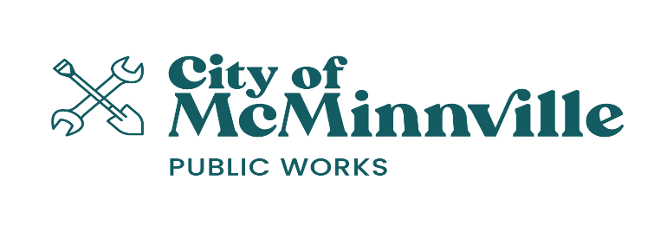
Important Advance Notice of
STREET CLOSURES
for Slurry Preservation Work

A Street Improvement Scheduled is for your Neighborhood Beginning July 11th through July 18th

In addition to this notice, your street will be posted a minimum of 24 hours in advance of the slurry seal application. A map of the schedule is attached.

Slurry seal is a protective coating that preserves the quality of the street, extends its life and protects the investment in our city streets. This project is part of the City’s 2024 annual Street Maintenance Program. Because this maintenance will cause some temporary inconvenience to our citizens we ask for your patience and cooperation.

To perform this work, we need your assistance in the following ways:

- Each street will be completely closed during the slurry seal process; it takes approximately 5 hours for the application and curing process depending on weather.

- Emergency vehicles such as police, fire and medical will not be restricted.

- No parking or driving on this street will be permitted during this time.

- ILLEGALLY PARKED VEHICLES, TRAILERS OR OTHER EQUIPMENT WILL BE TOWED AT OWNERS EXPENSE. Overnight and weekend parking will be permitted, however, the no parking restrictions will be enforced on weekdays beginning at 7:00 AM.

- Project streets must remain dry during the application of the slurry. Water is damaging to the effectiveness of the seal. Automatically controlled sump pumps must be turned off and automatic sprinklers adjusted to prevent overspray or runoff. There can be no watering of lawns, washing of cars or other activities that will allow water to run onto the street the day before or after completion of your street.

- All trees, shrubs and vegetation must be trimmed to allow full access to the surface of the street.

- If your plans include visitors, deliveries or a garage sale please schedule around this maintenance.

- Do not store gravel, landscape or building materials on the street.

Thank you for your patience and cooperation!

Slurry Seal Pavement Improvements
Q & A’s

Q. What is a slurry seal?
A. A slurry seal is a liquid mixture of asphalt and aggregate spread over the surface of the street. It is a hard wearing surfacing that protects, preserves and extends the pavement life. After curing it provides a pavement that is better to drive on, look at and will reduce the cost in the long run.
Q. Why was my street chosen?
A. Though your street is in basically sound condition, it needs routine maintenance to protect it. Slurry sealing and related maintenances replaces the wearing surface, minimizes raveling and retards water from seeping through the surface which damages the pavement and road base. A slurry seal is effective for 5-7 years. It costs less to apply preservation maintenances than to repair or replace the street.
Q. How long does the process take?
A. First the street must be swept clean and then the slurry is applied to the surface using a spreader box and squeegees. The slurry needs approximately 3 to 5 hours to cure from the time of application. Weather will factor into the curing time.
Q. What if it rains?
A. Slurry seals must be applied to a dry surface. That is also why it is important to make sure any sprinklers are turned off before and during the slurry seal work. If it is raining or if rain is in the forecast we will postpone and reschedule the construction.
Q. What about parking my car?
A. Overnight and weekend parking will be permitted, however, the no parking restrictions will be enforced on weekdays beginning at 7:00 am. All cars will need to be off the street surface and adjacent shoulders. You will be notified with a 24 hour final notice and No Parking signs will be posted. The entire street surface must be available for the work crews. Please also let family, friends and delivery people know not to park their vehicles on the street during that time period. Cars illegally parked will be towed at the owner’s expense. If your car is towed, contact the McMinnville Police Department at 503-434-7307.
Q. What should I do to prepare for the surface seal?
A. All trees shall be trimmed to a height of 13 feet above the street surface allowing clearance for construction equipment. All shrubs and vegetation shall be trimmed off the street surface and behind the curb to allow the equipment access to the entire street surface. Turn off all sprinklers and sump pumps the day before the seal. Please schedule visitors, deliveries, garage sales or events around this maintenance.
Q. What if I get slurry seal on my car or clothing?
A. When first applied the seal is wet and sticky. The wet surface sticks to tires (auto, bikes and skateboards), shoes, feet and pets. Therefore, it is important to avoid contact with the seal until it is dry to avoid tracking the sticky substance into your home or business. If you do get the seal on something, try to remove it as soon as possible with soap and water. If it has dried a bit and soap and water doesn’t work, use a solvent such as a citrus based degreaser, spray lubricant, or a household degreaser such as Goo Gone, WD-40 or Simple Green.
Q. How will I know when the work is completed?
A. The no parking construction signs will be removed and the street will be open for normal traffic flow and access. The street surface hardens with age and will be semi-soft and tender for several weeks after the application. We appreciate every effort to minimize the damage caused by hard braking, fast accelerating and sharp turning for a few weeks after the application. Because some raveling of small aggregate is normal and expected, periodic sweeping is scheduled for a few weeks.

For questions or additional information about this project, please call:
Engineering Services at 503-434-7312

